**Project Design Phase-II**

**Data Flow Diagram & User Stories**

|  |  |
| --- | --- |
| Date | 03 October 2022 |
| Team ID | PNT2022TMID53936 |
| Project Name | Project – Crude Oil Price Prediction |
| Maximum Marks | 4 Marks |

**Data Flow Diagrams:**

A Data Flow Diagram (DFD) is a traditional visual representation of the information flows within a system. A neat and clear DFD can depict the right amount of the system requirement graphically. It shows how data enters and leaves the system, what changes the information, and where data is stored.

**Example:** [**(Simplified)**](https://developer.ibm.com/patterns/visualize-unstructured-text/)

**](https://developer.ibm.com/patterns/visualize-unstructured-text/)**

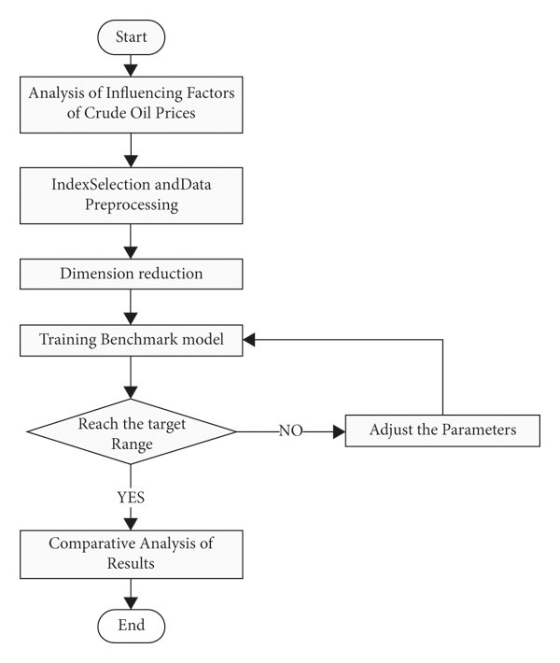

Example: DFD Level 0 (Industry Standard)

**User Stories**

Use the below template to list all the user stories for the product.

| **User Type** | **Functional Requirement (Epic)** | **User Story Number** | **User Story / Task** | **Acceptance criteria** | **Priority** | **Release** |
| --- | --- | --- | --- | --- | --- | --- |
| Customer (Mobile user) | Application | USN-1 | You can download the crude oil price by opening the Google Play Store app directly as a user. | I can access my account / dashboard | High | Sprint-1 |
|  | Available Products | USN-2 | Users of the application may instantly update the energy and oil prices while using it because there are so many different products in the crude oil price app | I can receive confirmation email & click confirm | High | Sprint-1 |
|  | Additional Features | USN-3 | Users can read the most recent news and see oil price charts. Major Energy Quotes User View The user may use many colour schemes. | I can register & access the dashboard with Facebook Login | Low | Sprint-2 |
|  | Expectations | USN-4 | User Can Convert Currency and Exchange Rates | I can expect | Medium | Sprint-1 |
|  | Login | USN-5 | Log in as a user without using your email address, username, or password. |  | High | Sprint-1 |
|  | Dashboard |  | View the overall status of crude oil pricing. |  |  |  |
| Customer (Web user) |  |  | I can see the prices of crude oil as a consumer | I can view the price directly. | High | Sprint-1 |
| Customer Care Executive |  |  | I am the user and I execute the pricing history. | I can accept the terms. | Medium | Sprint-1 |
| Administrator |  |  | As a manager, it anticipates the results. | Show the result. | High | Sprint-1 |
|  |  |  |  |  |  |  |
|  |  |  |  |  |  |  |
|  |  |  |  |  |  |  |